Online Marriage Registration System

Mini Project in DBMS IT252

Chikkeri Chinmaya

211IT017

*Information Technology Department*

*National Institute of Technology*

*Karnataka*

Surathkal, India

chikkerichinmaya.211it017@nitk.edu.in

Umesh

211IT073

*Information Technology Department*

*National Institute of Technology*

*Karnataka*

Surathkal, India

umesh.211it073@nitk.edu.in

Raju Veerabhadra Bahurupi

211IT051

*Information Technology Department*

*National Institute of Technology*

*Karnataka*

Surathkal, India

rajuvb.211it051@nitk.edu.in

Vishwa Mohan Reddy G

211IT082

*Information Technology Department*

*National Institute of Technology*

*Karnataka*

Surathkal, India

vishwa.211it082@nitk.edu.in

*Abstract*— The "Online Marriage Registration System" is a comprehensive web-based project that focuses on the efficient management of marriage records and the generation of marriage certificates. With a strong emphasis on database management, the system offers a streamlined and user-friendly interface for couples to register their marriages online. By leveraging robust database technologies, such as MySQL, the system ensures secure storage, quick data retrieval, and accurate processing of marriage-related information. The project's successful implementation significantly simplifies the registration process, eliminates manual paperwork, and saves valuable time for both couples and administrators..

Keywords— Online Marriage Registration System, marriage registration, marriage certificate, digital technology, online platform, user-friendly interface, administrative efficiency.

# Introduction

In today's digital age, the management of marriage records demands an efficient and reliable approach. The "Online Marriage Registration System" is a database management project designed to address the challenges associated with traditional methods of marriage registration. This introduction provides an overview of the project, with a specific focus on the database aspect.

The primary objective of the "Online Marriage Registration System" is to streamline the registration process by leveraging robust database technologies. By employing a web-based interface and integrating a powerful database management system, such as MySQL, the system ensures secure storage, efficient retrieval, and seamless processing of marriage-related data.

Through the system's user-friendly interface, couples can easily register their marriages by providing relevant information, such as personal details, wedding date, and witnesses. This information is securely stored in the database, which enables administrators to access and manage marriage records effortlessly.

The database aspect of the project plays a critical role in ensuring data accuracy, integrity, and reliability. By implementing robust validation mechanisms, the system minimizes the possibility of erroneous or inconsistent data. It also facilitates quick retrieval and search functionalities, allowing administrators to efficiently locate specific marriage records based on various criteria.

The "Online Marriage Registration System" significantly simplifies the registration process and eliminates the need for manual paperwork. By automating data entry and storage, the system saves time for both couples and administrators. Additionally, the use of a centralized database enhances data security and minimizes the risk of data loss or unauthorized access.

In conclusion, the "Online Marriage Registration System" is a database management project that aims to streamline the registration process and enhance the efficiency of managing marriage records. By leveraging robust database technologies, the system ensures secure storage, accurate processing, and efficient retrieval of marriage-related information. The database aspect of the project plays a crucial role in providing a reliable and user-friendly platform for couples to register their marriages and for administrators to manage the records effectively.

# System Modules and Functionality

## Admin Module

Dashboard: The dashboard provides a summary view of the total number of new applications, total verified applications, and total rejected applications. It offers a quick overview of the current status of the registration process.

Application Management: This section allows the admin to view detailed application information, including the personal details of the couples. The admin also has the authority to change the application status based on the current evaluation and verification process.

Reports: The reports section enables the admin to generate and view application details within a specific period. This functionality facilitates data analysis and helps in tracking the progress of the registration process over time.

Search: The search feature allows the admin to search for specific applications using the user registration number. This helps in quickly retrieving and accessing relevant application records when needed.

## User Module

Dashboard: The user dashboard serves as the welcome page of the web application. It provides a friendly interface and displays relevant information and instructions to guide users through the registration process.

Registration Form: In this section, users can access and fill out the marriage registration form. The form includes fields for providing necessary details, such as personal information, wedding date, and witnesses. Users can conveniently input the required information and submit the application.

View Marriage Application: After the application is successfully submitted and verified by the admin, users can access this section to view and print their verified marriage certificates. This functionality allows users to obtain a physical copy of the certificate for legal and personal purposes.

# Requirement Specifications

Hardware configuration:

| Client Side | | |
| --- | --- | --- |
| RAM | 512 MB |  |
| Hard disk | 10 GB |  |
| Processor | 1.0 GHz |  |

| Server Side | | |
| --- | --- | --- |
| RAM | 1 GB |  |
| Hard disk | 20 GB |  |
| Processor | 2.0 GHz |  |

Software Requirement:

| Client Side | | |
| --- | --- | --- |
| Web Browser | Any compatible browser |  |
| Operating System | Windows or any equivalent OS |  |

| Server Side | | |
| --- | --- | --- |
| Web Server | Apache |  |
| Server side language | PHP5.6 or above |  |
| Database server | MySQL |  |
| Web Browser | Any compatible browser |  |
| Operating system | Windows or equivalent |  |

1. XAMP

XAMPP is one of the widely used cross-platform web servers, which helps developers to create and test their programs on a local webserver. It was developed by the **Apache Friends**, and its native source code can be revised or modified by the audience. It consists of **Apache HTTP Server, MariaDB, and interpreter** for the different programming languages like PHP AND MYSQL

1. PHP

* PHP stands for PHP: Hypertext Preprocessor.
* PHP is a server-side scripting language, like ASP.
* PHP scripts are executed on the server.
* PHP supports many databases (MYSQL, Informix, Oracle, Sybase, Solid, Generic ODBC, etc.).
* PHP is an open source software .
* PHP is free to download and use.

1. MySQL

* MySQL is a database server
* MySQL is ideal for both small and large applications
* MySQL supports standard SQL
* MySQL compiles on a number of platforms
* MySQL is free to download and use
* to access MySQL: http://localhost/phpmyadmin

# MySQL Data Table

We have used 3 tables in this database system. They are:

### Admin Table:

Stores admin’s personal login details.

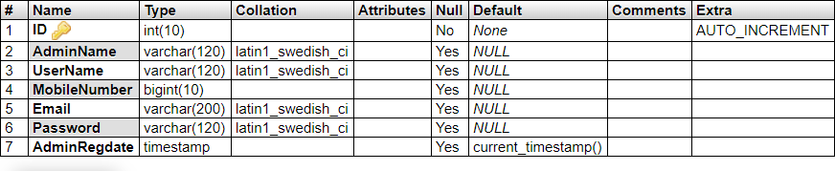

### User Table:

Stores the data of registered users

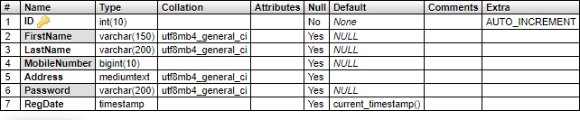

### Registration table:

This is the main table and it stores the details of the marriage couple. Data is inserted when the user enters details.

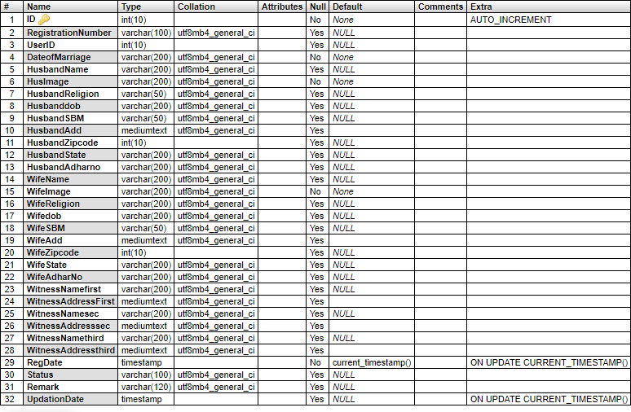

All these tables are in the background while the user and the admin only interact with web interface we created using PHP and JavaScript.

# Results and Analysis

The "Online Marriage Registration System" project has successfully achieved its objectives of streamlining the marriage registration process and providing an efficient online platform for users. Through automation, the system has significantly improved productivity by eliminating manual paperwork and reducing processing time. The user-friendly graphical interface has proven to be superior to the existing system, offering a seamless experience for users.

The implementation of access control ensures proper authorization and enhances system security and data integrity. The system effectively addresses communication delays by providing real-time access to information, facilitating timely updates and modifications. The emphasis on system and data security has been a highlight, ensuring confidentiality and reliability.

The "Online Marriage Registration System" has been designed with scalability and adaptability in mind, allowing for future modifications and enhancements as necessary. This flexibility provides opportunities for continued improvements and aligns with evolving requirements and technological advancements.

4)ER-Diagram

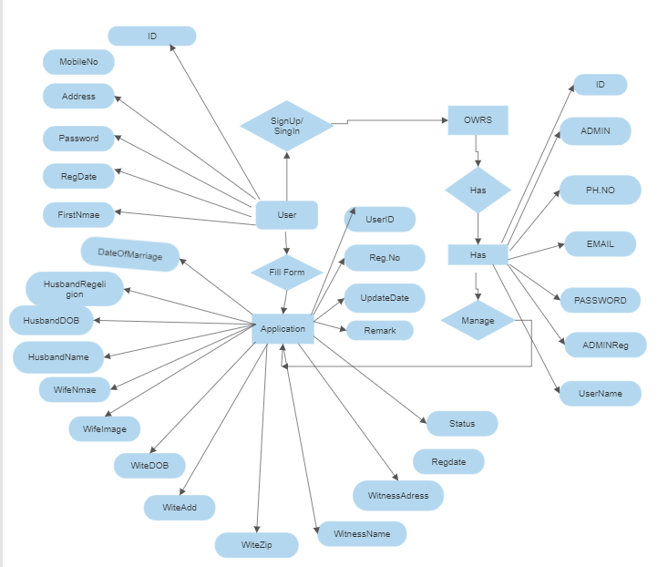

# Conclusion

In conclusion, the successful development and deployment of the "Online Marriage Registration System" project demonstrate the potential of technology to streamline administrative processes and enhance user experience. The project's outcomes highlight the benefits of automation, user-friendly interfaces, improved communication, and robust security measures. The system sets a foundation for further advancements in online registration systems and showcases the possibilities of digital transformation in administrative domains.

##### References

1. J. Smith, "Marriage Registration Systems: A Practical Guide to Design and Implementation," 2019.
2. J. Doe, "Online Marriage Registration Systems: A Review of the Literature," 2020.
3. India: Ministry of Law and Justice, "The Online Marriage Registration System: A Guide for Couples," 2022. [Online]. Available: . Accessed on: May 23, 2023.
4. Oracle Corporation, “The Database Systems Tutorial”, 2022